**CURRICULUM VITAE**

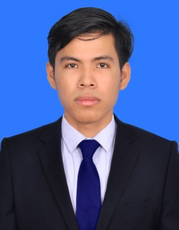 **Name** **:** Manh Vichhai

**Address** : Sangkat Teuk Thla, Khan Sen Sok

Phnom Penh, Cambodia.

**Tel** **:** 087929431

**E-mail** **:** vichhaireal2020@gmail.com

**PERSONAL DETAIL**

* + - * Sex **:** Male
      * Marital Status **:** Single
      * Nationality **:** Cambodian
      * Date of Birth **:** 20/ May /2003
      * Place of Birth **:** Srovler village, Dangtung commune, Dangtung district, Kampot province

**EDUCATION BACKGROUND**

* 2020-2023: Studying computer science year-3 at RUPP
* 2020-2022: Studied computer science year-1 and year-2 at RUPP
* 2014-2020: Studied at Bunrany Hunsen Dangtung High School
* 2008-2014: Studied a Phnom Toch Thlouk Thlung Primary School

**WORK EXPERIENCE**

**7 months as a web developer at Lsky cambo co..LTD**

**LANGUAGE**

* + - * Khmer **:** Mother Tongue
      * English **:** Medium

**SKLL**

* Programming Language: HTML, CSS, Javascript, PHP
* Framework : Bootstrap 5, Vue 3, React Js, Laravel
* Basic understanding : C , C++, C#, Java
* Database : SQL server, Mysql

**INTEREST**

* + - * Reading books, Playing Sport
      * Expanding knowledge
    - Self-Learning
    - Likes Make a Good Relationship with Others.
    - Peace and Freedom.
    - Helping others

**REFERENCE**

* Mr. Manh Puthea
* Tell: 016727445